**Siddhant Mundhe**

**Data engineering batch 1**

**Day 11 assignment**

**Pyspark = Python + Apache Spark**

**Installing Required Softwares :**

**Java installation**

As java was already installed on my computer checked as if it is working fine or not

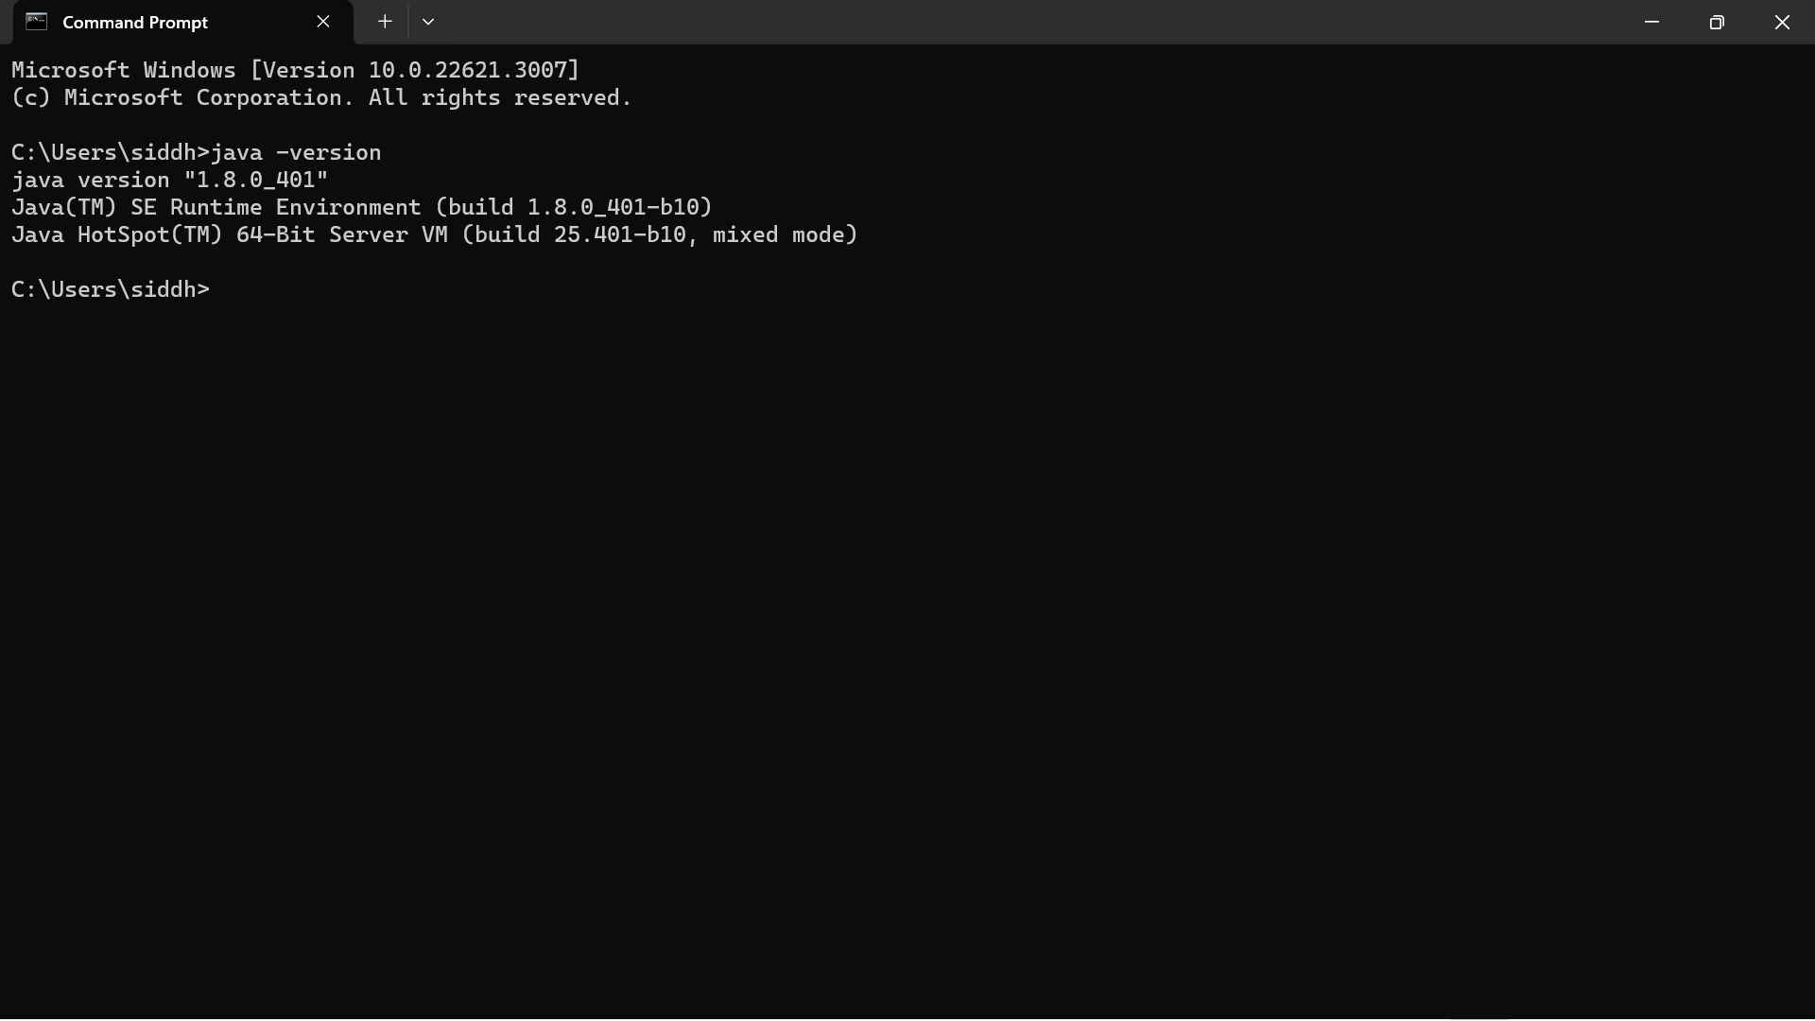

**Python Installation**

Python was also installed in the system also checked version for it

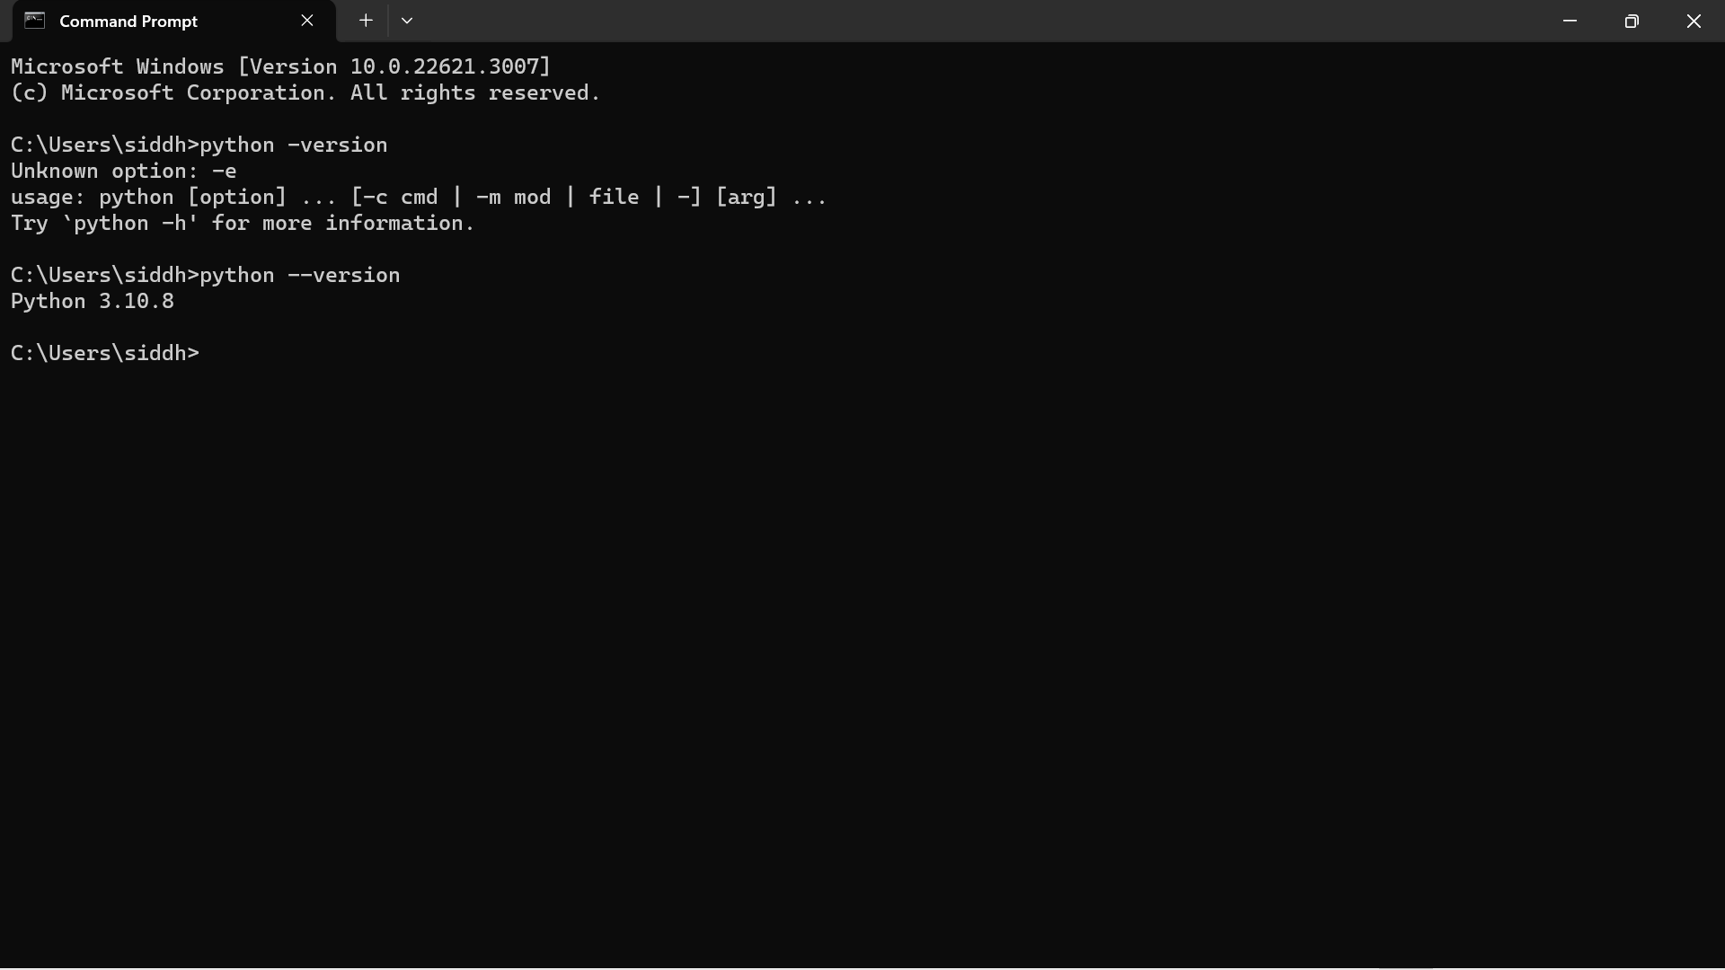

### Installing Pyspark

· Head over to the spark homepage

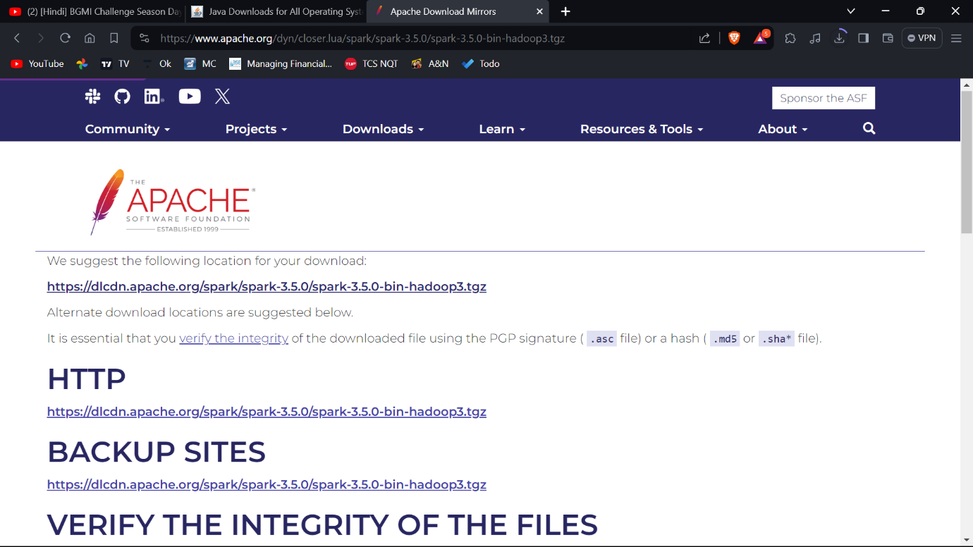

**Extract Spark: •**

**Extract the downloaded ZIP file to a location on your machine (e.g., C:\spark\).**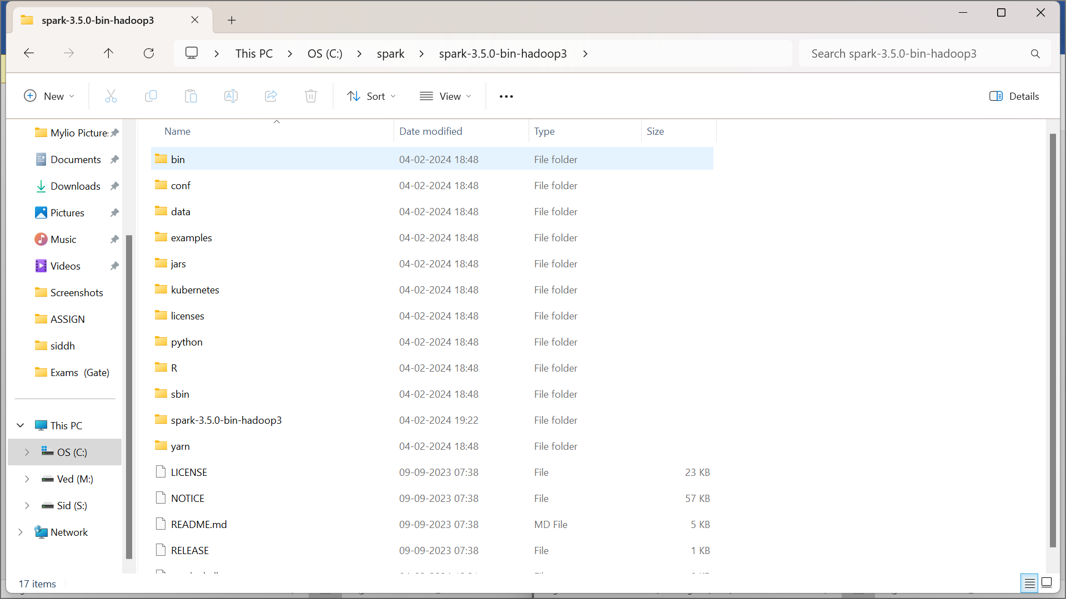

### Download and setup winutils.exe

### Download using these link

### <https://github.com/cdarlint/winutils>

Extract Hadoop: Extract the downloaded Hadoop binary to a location on your machine (e.g., C:\hadoop).

**Using Environment Variables**

**Set path for**

**JAVA_HOME - C:\Program Files\Java\jdk-17**

**SPARK_HOME C:\spark\extractedfile_name**

**PYTHON**

**HADOOP_HOME c:hadoop\bin**

**Configure System Environment Variables**

**Edit System Path:**

**Add the following entries to the system PATH environment variable:**

**%JAVA_HOME%\bin**

**%SPARK_HOME%\bin**

**Run on cmd or powershell**

**Pyspark**

**OUTPUT**

